1st Annual “Waterfront Field of Dreams”
Cornhole Tournament
July 3rd, 2021 11 am, 1 pm & 3pm

Join the fun and show off your cornhole skills!

All funds raised will go towards the Waterfront Field of Dreams project which plans to build a new baseball/softball field in the same waterfront location with new concessions, stadium seating, low maintenance turf, new restrooms, and LED lighting.

3 Skill Levels: Guaranteed two games per team

11 am: Level One – Beginners young and old, $15 per person and 16 teams max

1 pm: Level Two – Middle & High School Teams, $20 per person and 16 teams max

3 pm: Level Three – Adult & advanced high school, $20 per person and 16 teams max

Sign up on Friday, July 2nd from 7 - 8 pm at Sunset Park by the Log Cabin and Saturday, July 3rd beginning at 10 am. Cash only, exact donations please.

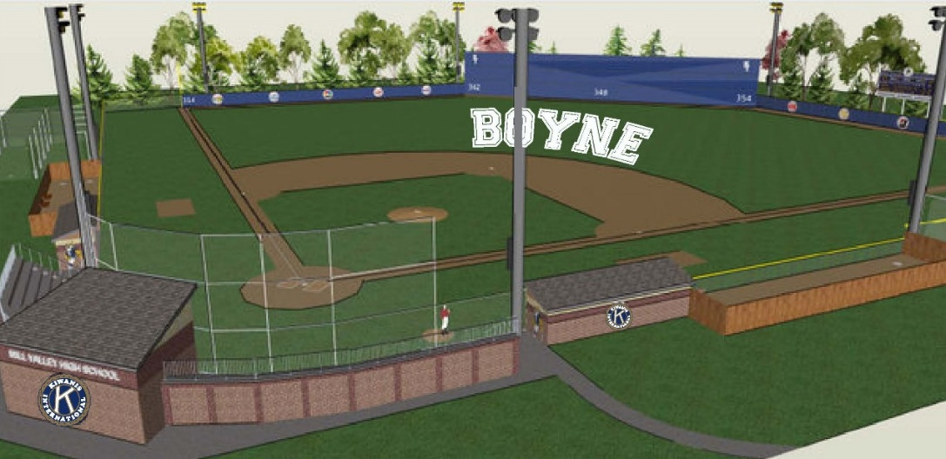
www.waterfrontfieldofdreams.com

