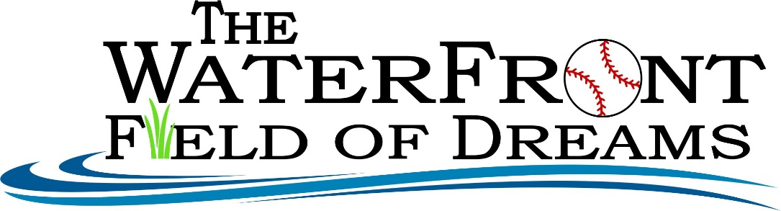

2nd Annual
Cornhole Tournament
July 2nd, 2022 – 3 different times * 11 am, 1 pm & 3pm
Cash Prizes – 1st place team $100 2nd place team $50 - at each level
Join the fun and show off your cornhole skills!

All funds raised will go towards the Waterfront Field of Dreams project.

We are building a new baseball/softball field in the same waterfront location.

New concessions, stadium seating, new restrooms, LED lighting, and turf.

3 Skill Levels: Guaranteed two games per team

11 am: Level One – Middle School $15 per person and 16 team max

1 pm: Level Two – High School and adult $20 per person and 16 team max

3 pm: Level Three – Competitive $20 per person and 16 team max

Sign up on Friday, July 1st from 7 - 8 pm at Sunset Park & Saturday, July 2nd at 10 am. Cash only, exact donations please.

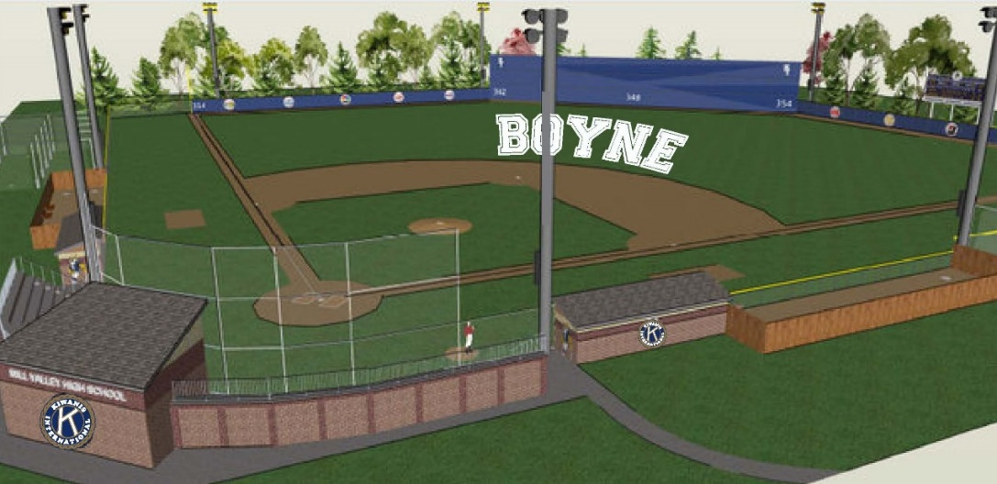
www.waterfrontfieldofdreams.com

